What is an OpenDaylight Controller?

Hosted by the [Linux Foundation](http://www.linuxfoundation.org/), [OpenDaylight Project (ODL)](https://www.sdxcentral.com/sdn/definitions/opendaylight-project/" \o "What is the OpenDaylight Project?) is an [open source](https://www.sdxcentral.com/cloud/open-source/) SDN project aimed at enhancing [software-defined networking (SDN)](https://www.sdxcentral.com/sdn/) by offering a community-led and industry-supported framework for the OpenDaylight Controller, which has been renamed the OpenDaylight Platform. It is open to anyone, including end users and customers, and it provides a shared platform for those with [SDN](https://www.sdxcentral.com/sdn/definitions/what-the-definition-of-software-defined-networking-sdn/) goals to work together to find new solutions.

Under the Linux Foundation, OpenDaylight includes support for the [OpenFlow](https://www.sdxcentral.com/sdn/definitions/what-is-openflow/) protocol, but can also support other open [SDN](https://www.sdxcentral.com/nfv/definitions/which-is-better-sdn-or-nfv/) standards.

The OpenFlow protocol, considered the first SDN standard, defines the open communications protocol that allows the [SDN Controller](https://www.sdxcentral.com/sdn/definitions/sdn-controllers/) to work with the forwarding plane and make changes to the network. This gives businesses the ability to better adapt to their changing needs, and have greater control over their networks.

The OpenDaylight Controller is able to deploy in a variety of production network environments. It can support a modular controller framework, but can provide support for other SDN standards and upcoming protocols.

The OpenDaylight Controller exposes open [northbound APIs](https://www.sdxcentral.com/sdn/definitions/north-bound-interfaces-api/), which are used by applications. These applications use the Controller to collect information about the network, run algorithms to conduct analytics, and then use the OpenDaylight Controller to create new rules throughout the network.

The OpenDaylight Controller is implemented solely in software, and is kept within its own Java Virtual Machine (JVM). This means it can be deployed on hardware and operating system platforms that support [Java](https://www.java.com/en/). For best results, it is suggested that the OpenDaylight Controller uses a recent Linux distribution and at least Java Virtual Machine 1.7.

For detailed SDN Controller Vendor and Open Source SDN Controller comparisons, checkout the [2017 Network Virtualization and SDN Controllers Report](https://www.sdxcentral.com/reports/2017/network-virtualization-sdn-controller/) also available as [PDF Download](https://www.sdxcentral.com/reports/network-virtualization-sdn-controllers-download-2017/)

Overview of OpenDaylight Controller and Software Releases

The first software code release for the OpenDaylight Controller is [Hydrogen](https://wiki.opendaylight.org/view/Release/Hydrogen/Base). It was the first simultaneous release of OpenDaylight, and features three different editions to help users get started: the Base Edition, the Virtualization Edition, and the Service Provider Edition. The three types of the software ensure a wide array of users can implement Hydrogen.

[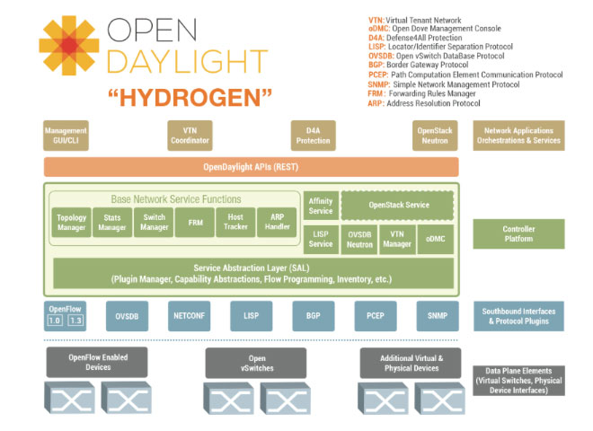](https://www.sdxcentral.com/wp-content/uploads/2014/09/opendaylight-controller-sdn.jpg)

The second code release for OpenDaylight Controllers is [Helium](https://wiki.opendaylight.org/view/Release/Helium/VTN/User_Guide). It features a new user interface, and a more simplified and customizable installation process, due to the use of the [Apache Karaf](http://karaf.apache.org/) container. This code release also has deeper integration with [OpenStack](https://www.sdxcentral.com/cloud/open-source/definitions/what-is-openstack-quantum-neutron/), including improvements in the [Open vSwitch](https://www.sdxcentral.com/cloud/open-source/definitions/what-is-open-vswitch/) Database Integration project, as well as other features like Security Groups, Distributed Virtual Router, and Load Balancing-as-a-Service.

[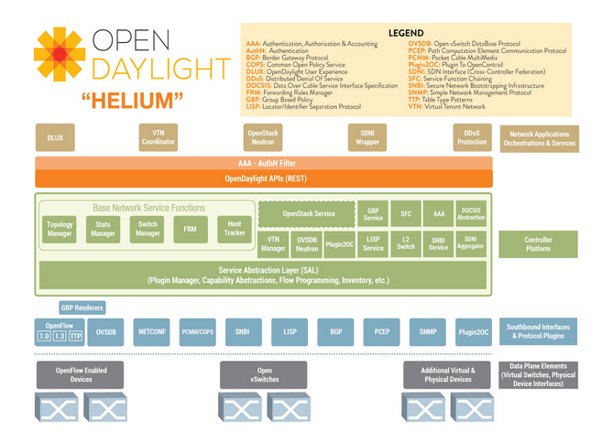](https://www.sdxcentral.com/wp-content/uploads/2014/09/Screen-Shot-2014-11-21-at-11.17.45-AM.png)

The OpenDaylight Project is launched it’s  third software release, [Lithium](https://wiki.opendaylight.org/view/Simultaneous_Release:Lithium_Release_Plan), in summer 2015.  With The Lithium release, ODL has repositioned the OpenDaylight Controller as the OpenDaylight Platform.  The next release, as shown below, is [Beryllium](https://wiki.opendaylight.org/view/Simultaneous_Release:Beryllium_Release_Plan), currently slated for late 2016 release.  ODL is also planning and early 2017 release, code named Boron.